**Steps of Customer creation(Private)-**

1. Click on “Customer Maintenance” from left hand side menu or under common funcations

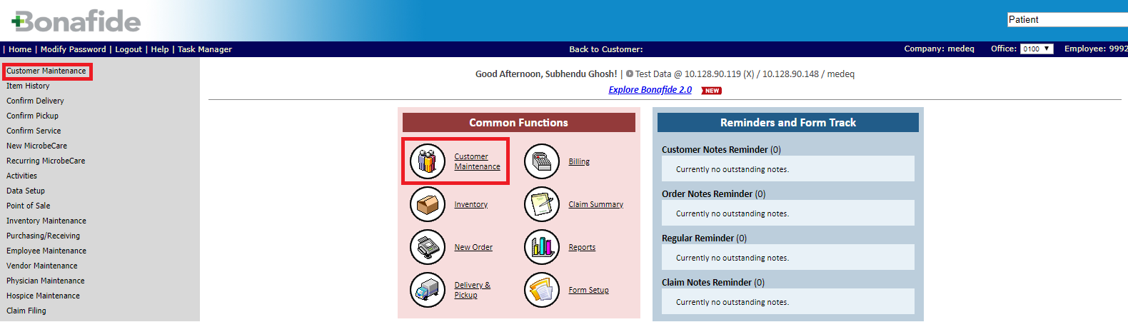

1. Click on “Add New Patient” link under Available Actions

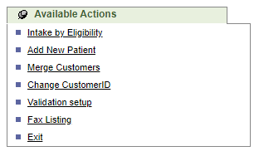

1. Enter all the required fields like- SSN

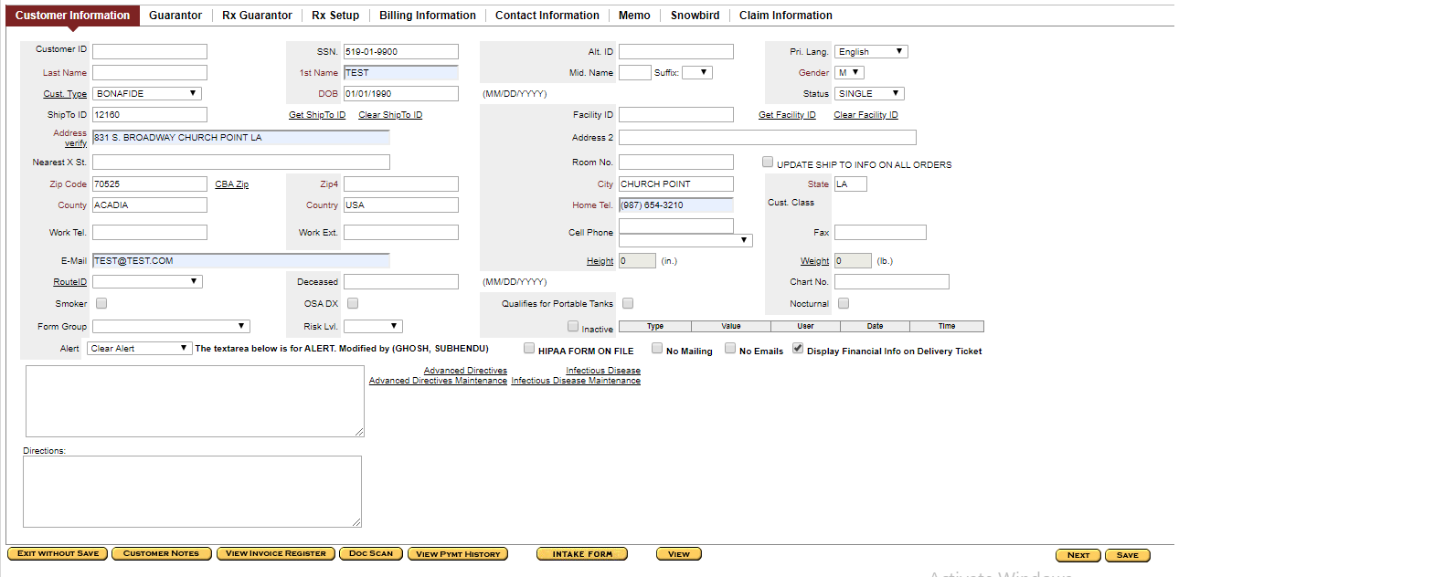

1. Click on “Save” button
2. A new unique Customer id will be generated

Please check the below newly created customer- 12160 as reference.

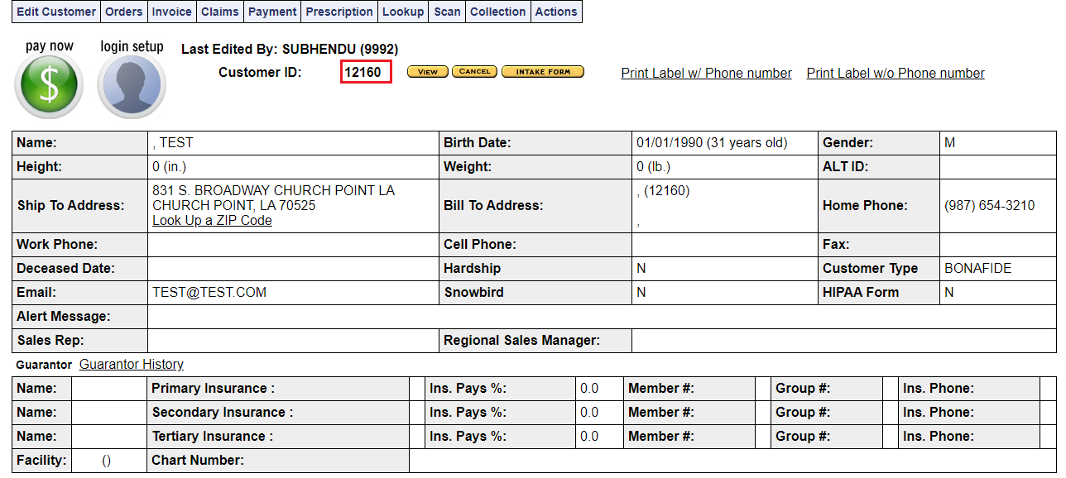

**Steps of Customer creation with insurance (Guarantor)**

1. Click on “Customer Maintenance” from left hand side menu or under common funcations



1. Click on “Add New Patient” link under Available Actions



1. Enter all the required fields like- SSN

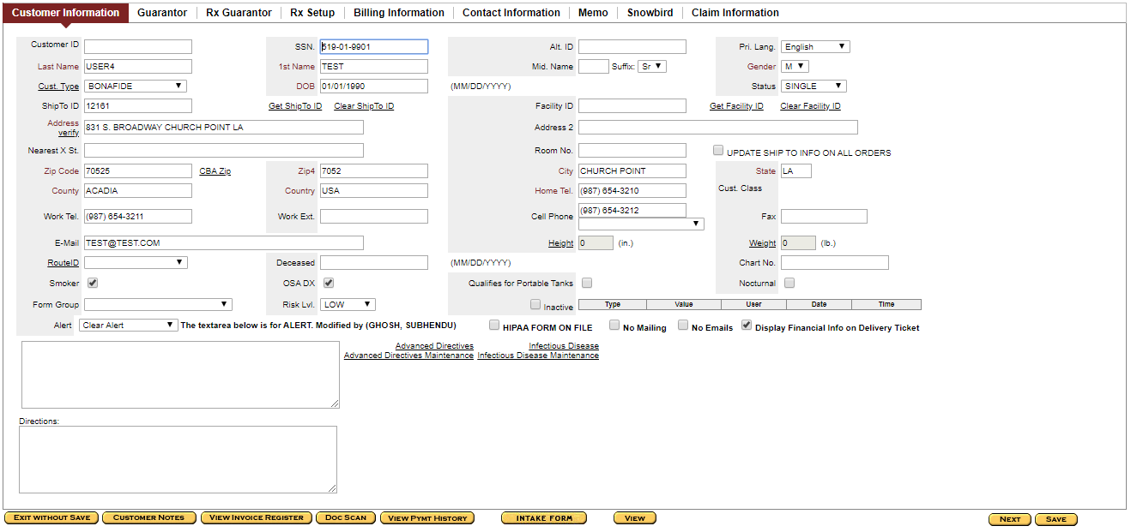

1. Go to “Guarantor” tab
2. Enter all insurance details

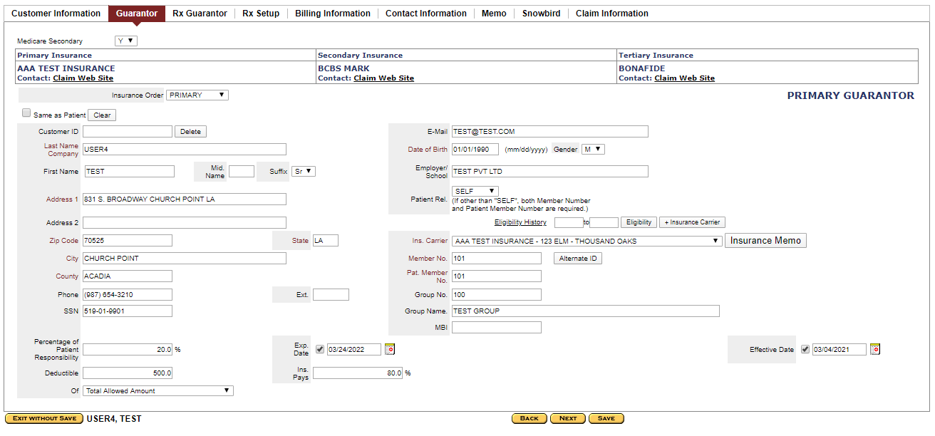

1. Click on “Save” button
2. A new unique Customer id will be generated

Please check the below newly created customer- 12161 as reference.

